Deworming

Medicines
1 | Liv52 | 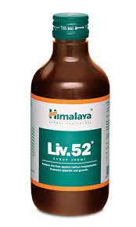
2 | Albomar | 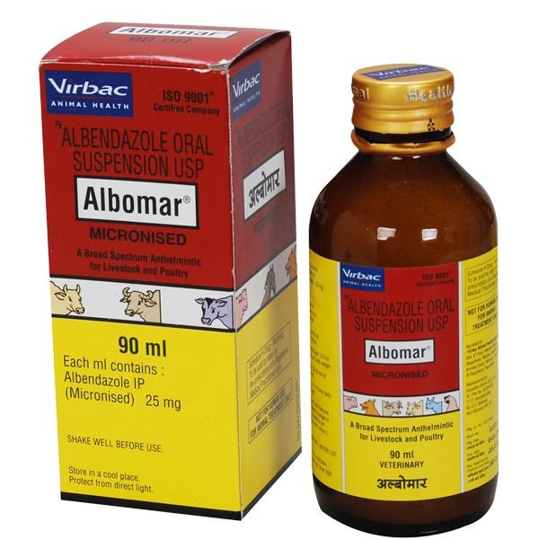
3 | Vimeral | 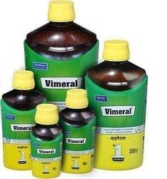
4 | Osto Vet or Zinco Vet | 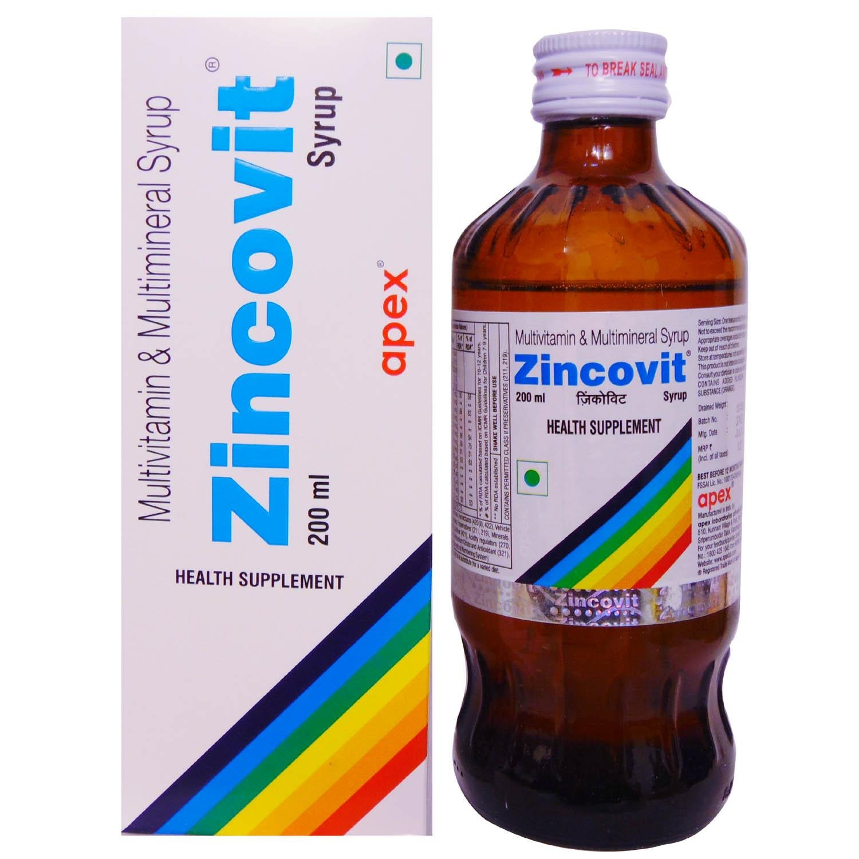  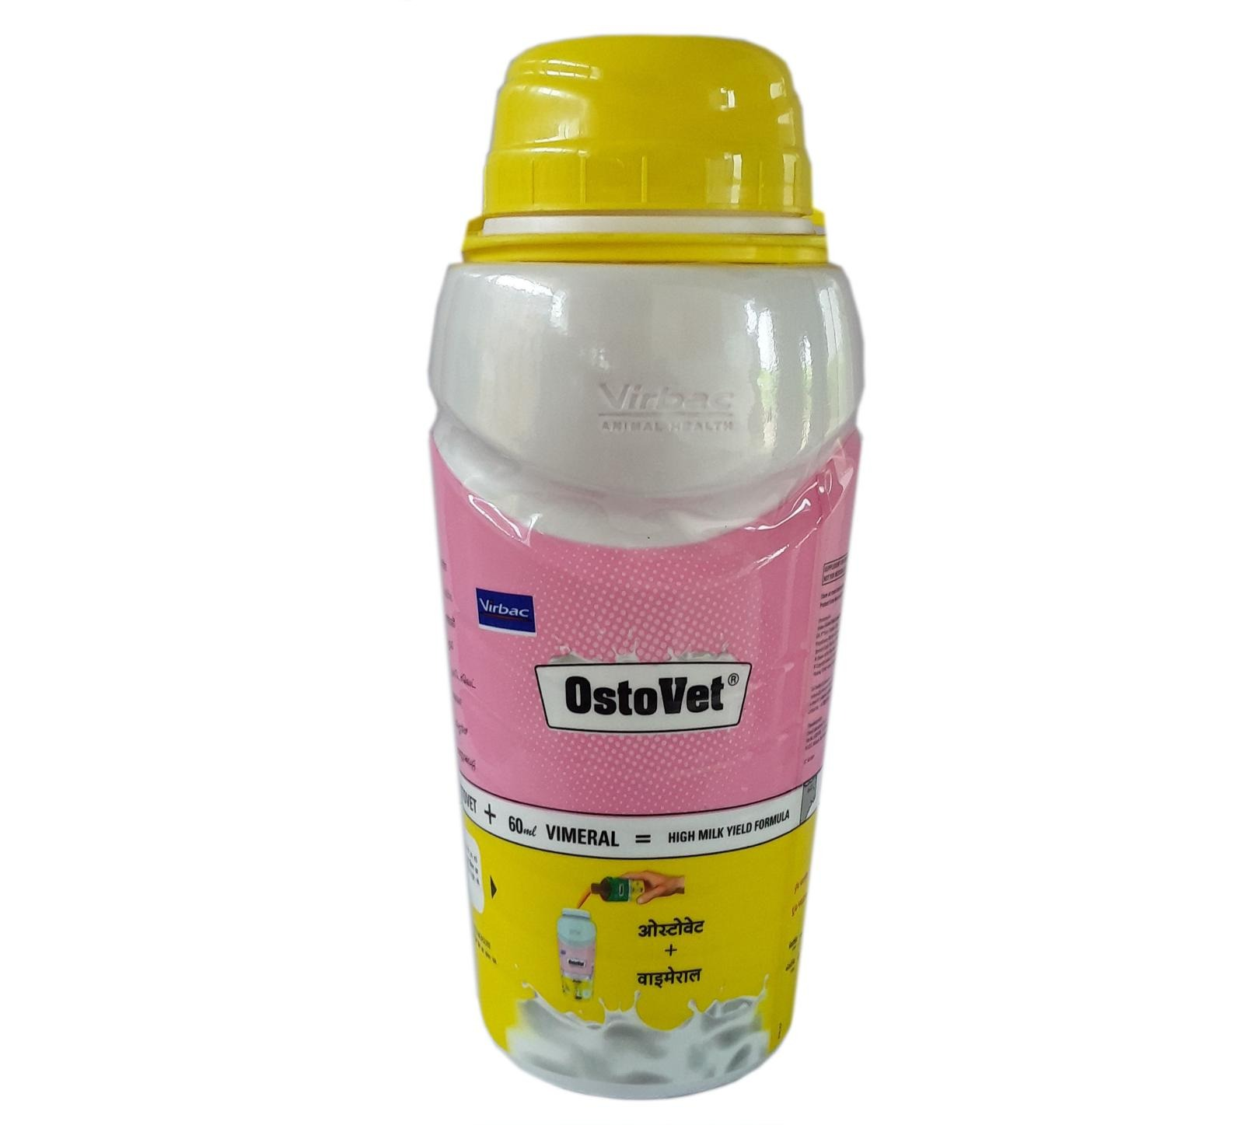

Usage

Day 1 and 2 | - Liv52 1ml in 1 litre of water.  - Keep water at 7:00 am and remove at 5:00pm including food.  - Remove water and food  - Keep only dry seeds, no soaked foods
Day 3 | - Albomar 5ml in 1 litre of water  - Keep water at 7:00 am and remove at 3:00.  - Keep fresh water after that.  - Remove water and food at night.  - Keep only dry seeds, no soaked foods
Day 4 and 5 | - Liv52 1ml in 1 litre of water.  - Keep water at 7:00 am and remove at 5:00pm including food.  - Remove water and food  - All types of food
Day 6 - 10 | - Vimeral 1ml in 1 litre water  - Keep water at 7:00 am and remove at 5:00pm including food.  - Remove water and food  - All types of food.
Day 11 and 12 | - Vimeral 1ml in 1 litre water  - OstoVet 2ml in 1 litre water  - Keep water at 7:00 am and remove at 5:00pm including food.  - Remove water and food

